Question 2

* First I have created one directory for script.
* Next I went into that directory.
* Next I wrote backup code then executed it.

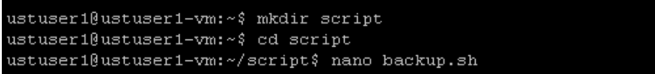

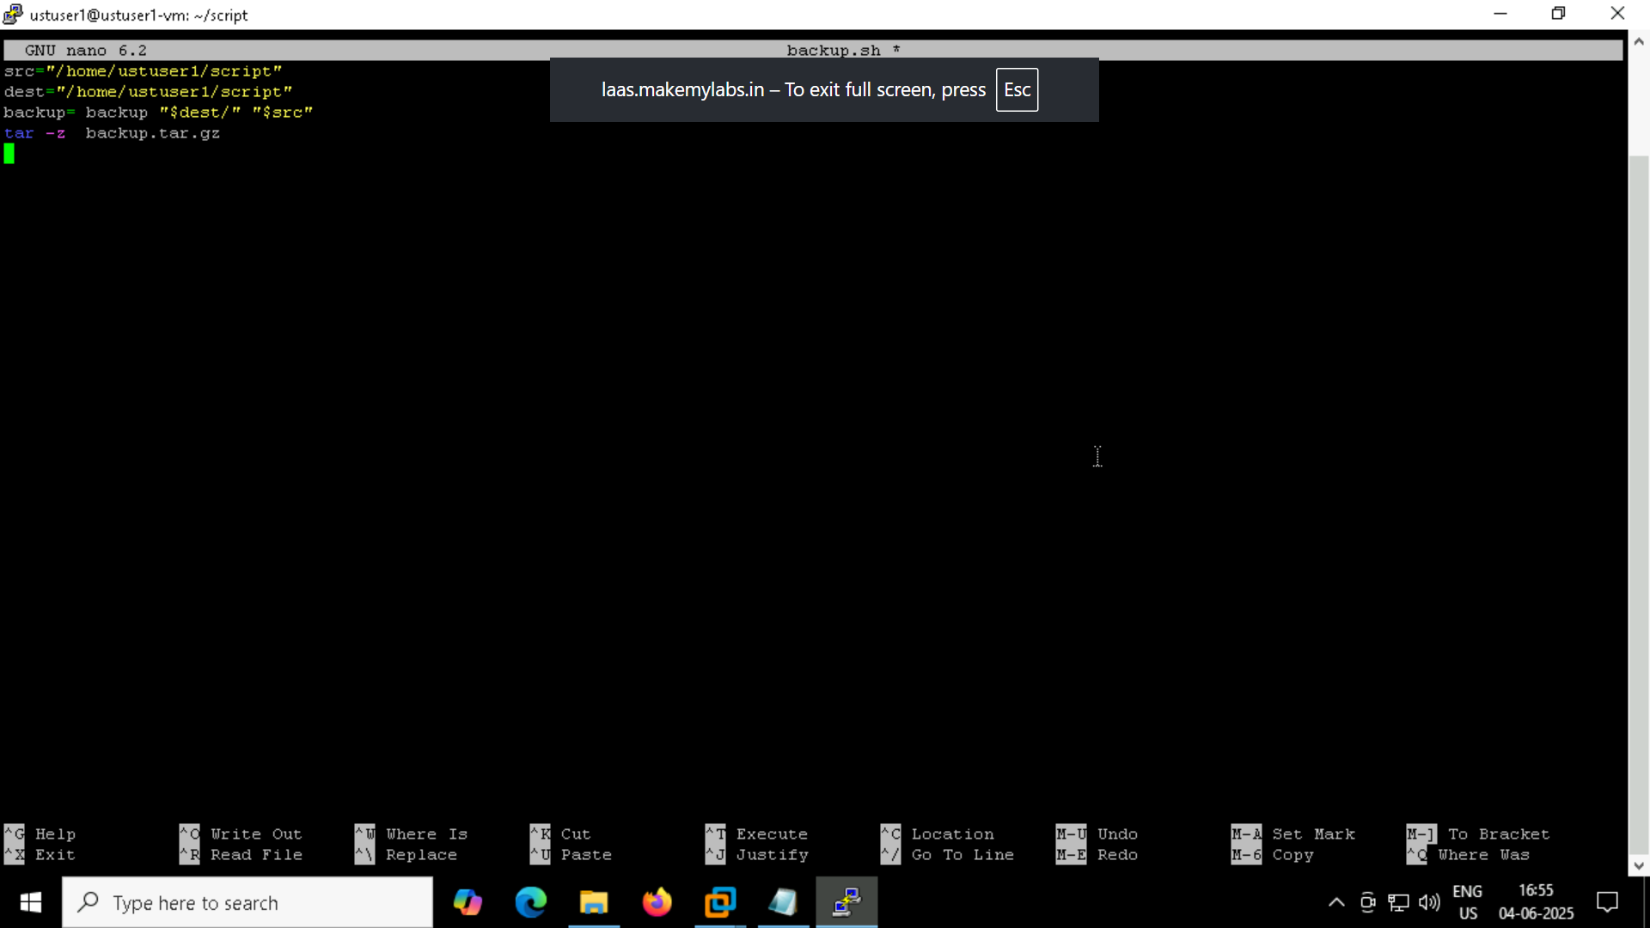

Output backup file is created as I specified backup past as /home/ustuser1/script

